**Mathematics Methods  
YEAR 11**

**Investigation 1 – Linear Functions, Pascal’s Triangle and Binomial Expansion**

**Semester 1 2020**

**Time allowed:** One period

**Marks Available:** 35 marks

**Materials required:** Writing implements, correction fluid/tape or eraser, ruler, Scientific calculator, ClassPad.

**Instructions:**

1. Write your answers in the spaces provided in this Question/Answer Booklet.
2. **Show all your working clearly**. Your working should be in sufficient detail to allow your answers to be checked readily and for marks to be awarded for reasoning. Incorrect answers given without supporting reasoning cannot be allocated any marks. For any question or part question worth more than two marks, valid working or justification is required to receive full marks. If you repeat an answer to any question, ensure that you cancel the answer you do not wish to have marked.

**Part A (20 marks) – suggested time 40 minutes**

Three plumbers are competing for a particular contract. Your task it to determine which plumber should be given the contract. The average time to complete this contract given by industry sources is 5 hours with a variation of 2 hours either way.

* Action Plumbing charges a set fee of $100 and then $50 per half an hour.
* Champions Plumbing charges a set fee of $200 and then $20 per 15 minutes.
* U Bend Plumbing charges no set fee. The charge $130 per hour.

Note:

* You should justify any decisions using graphs and valid working.
* Introduce the task, complete your working showing verifiable mathematics including a graph(s) and offer a decision to your manager.

**Part A (9 marks) – suggested time 5-10 minutes**

The diagram is Pascal’s Triangle. Each number in the triangle is obtained by adding the numbers right and left above it. Rows 0 to 3 have been completed.

1. Complete the remaining rows. [3]

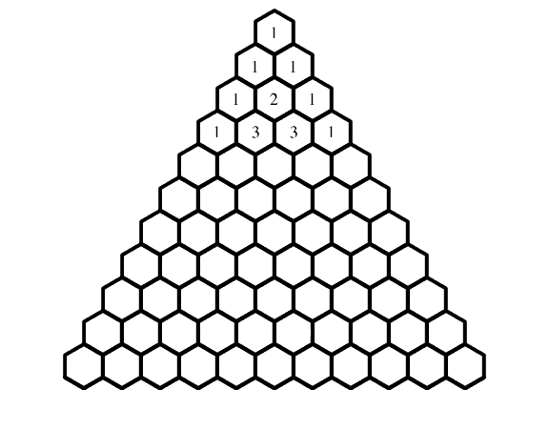

1. **Explain** three interesting features of Pascal’s Triangle. [6]

**Part B (6 marks) – suggested time 5-10 minutes**

**Algebraic Expansions**

Remember having to expand an expression like **(1 + x)2**

As a reminder, the expression is expanded like this:

**(1 + x)2 = (1 + x)(1 + x)**

**= 1 + 1x + 1x + x2**

**= 1 + 2x + x2 f**

Each term in the left bracket is multiplied by each term in the right bracket.

We can do the same with a cube, i.e (1 + x)3. Verify that the following is correct.

**(1 + x)3 = (1 + x)(1 + x)(1 + x)**

**= (1 + x)(1 + 2x + x2)**

**= 1 + 3x + 3x2 + x3**

1. (1 mark)  
   Comment on the **coefficients** of the resulting expansion of (1 + x)3.
2. (3 marks)  
   Prove, using algebra, that,

**(1 + x)4 = 1 + 4x + 6x2 + 4x3 + x4**

1. (2 marks)  
   Without using your ClassPad, determine and justify the expansion of (1 + x)7?

**End of Investigation**